Thermal Fractionation

Kristy Lam

# Thermal Fractionation

Thermal fractionation utilizes heat to characterize soil organic matter (SOM), then identify what types of soil organic carbon (SOC) are present in a given soil sample. However, these methods take proxy measurements and, therefore, require to be coupled with another fractionation method (i.e. chemical, physical, biological). Recent studies (see “Applications” section) have utilized these techniques to their advantage to answer relevant questions about SOM dynamics and stability.

“…thermal analysis is a highly integrative method that requires little sample preparation and allows the analysis of bulk soil samples without pretreatment, even with low C content. Using thermal analysis techniques to investigate SOM stability is highly attractive.”  
Peltre et al., (2013) DOI: [10.2136/sssaj2013.02.0081](https://www.soils.org/publications/sssaj/abstracts/77/6/2020)

“Analysis of the results revealed the suitability of thermal methods to provide simple, quick and reliable information on organic matter stabilisation during the composting process of agroindustrial residua.”  
Dell’Abate et al., (2000) DOI: [10.1023/A:1010157115211](https://link.springer.com/article/10.1023/A%3A1010157115211)

# Thermal Fractionation Methods

## A. Thermogravimetry (TG) & Differential Scanning Calorimetry (DSC)

This method involves two parts: thermogravimetry (TG) and differential scanning calorimetry (DSC). The former involves increasingly heating a sample in an inert or oxidative gas atmosphere that result in weight loss or gain. The changes in sample weight can be attributed to alterations in chemical or physical properties, thus TG is important in investigating thermal stability of SOM. The latter will plot a figure according to heat flow (i.e. exotherm vs endotherm reaction). DSC analyses do not require large samples, numerous controls, or extensive method development. In addition, this technique can be applied to whole soil sampling without requirement of pretreatments (i.e. chemical extraction) or isolated fractions.Check out this [video from Setaram](http://us.setaram.com/en/setaram-products/couplings-gas-analysis-2/tga-sta-ms/sensys-evo-tg-dsc-ega/1/).

Sources:  
EAG Laboratory (<https://www.eag.com/>)

## B. Pyrolysis Gas Chromatography-Mass Spectrometry (Py GC-MS)

This technique studies the chemical composition of plant material and polymers at the molecular scale. First, the sample is thermally fragmented through pyrolysis, then separated by gas chromatography. According to the mass-charge ratio and relative abundance, the sample is ionized and characterized. This method often provides useful information and insight on the origin of SOC/SOM. In a study conducted by Lara-Gonzalo et al. (2015), they were able to utilize Py GC-MS to quickly identify the majority of the contaminants present at the site, thus found it very useful as a screening system to obtain qualitative results in soil pollution studies. Although this technique only requires minimal sample preparation, Py GC-MS is a destructive technique and non-homogenous samples may lead to variable results. Common types of Py GC-MS analyses include: single shot, double shot, evolved gas anlysis, and much more. (click [here](https://www.eag.com/pyrolysis-gc-ms/) for a more comprehensive list)

Sources:  
Jimenez-Gonzales et al. (2017) DOI: [10.1016/j.chroma.2017.05.068](https://www.sciencedirect.com/science/article/pii/S0021967317308282)  
Lara-Gonzalo et al., (2015) DOI: [10.1016/j.orggeochem.2015.06.012](https://www.sciencedirect.com/science/article/pii/S0146638015001321)  
EAG Laboratory (<https://www.eag.com/>)

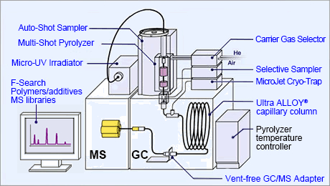

From [Frontier Lab](http://www.frontier-lab.com/english/multi-functional-pyrolysis-system/)

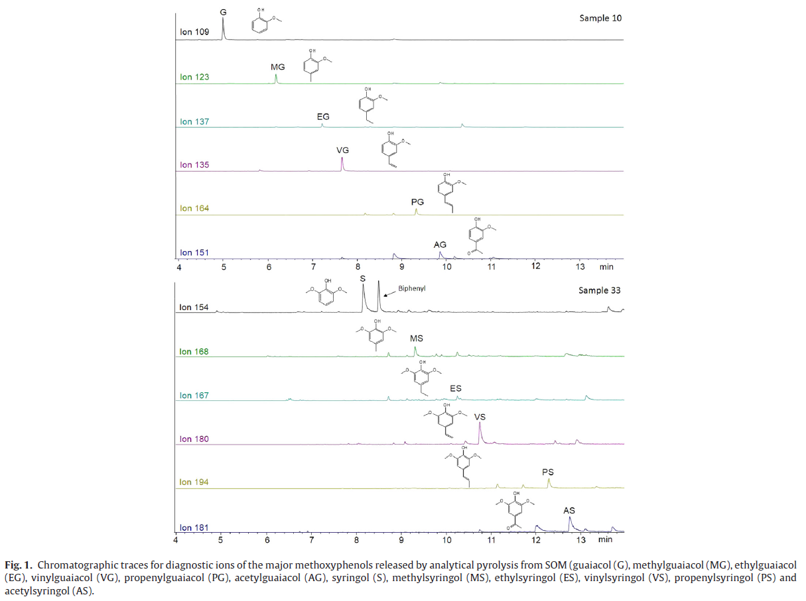

From Jimenez-Gonzales et al. (2007) DOI: [10.1016/j.chroma.2017.05.068](https://www.sciencedirect.com/science/article/pii/S0021967317308282)

# Applications

**SOM stability**

In 2013, Peltre et al. further assessed the relationships between thermal and biological indices of SOM stability using a wide range of soils with varying C concentrations collected from across the United States. Soils were analyzed using TG-DSC coupled with CO2–EGA. These measurements were compared with SOM biological stability measured during long-term laboratory incubations. Results showed that different relationships exist between the thermal and biological stabilities of SOM (i.e. differences in C concentrations), which can be attributed to different mechanisms of SOM stabilization. Thus, mineral association of SOM and abundance of intact plant debris are vital in low-C soils and high-C soils, respectively. DOI: [10.2136/sssaj2013.02.0081](https://www.soils.org/publications/sssaj/abstracts/77/6/2020)